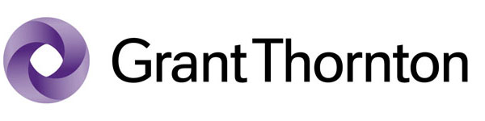
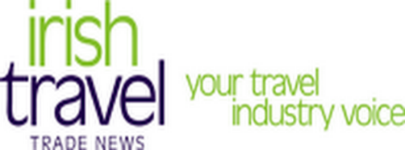
Votes Audited by:
Join in the Celebrations at the Networking
Event of the Year

The Irish Travel Trade Awards celebrate 23 years with the presentations to the winners at the Irish Travel Industry Christmas Party on Friday 28th November 2014 in the DoubleTree by Hilton Hotel Dublin Burlington Road, Dublin 2. The event is the highlight of the Irish travel industry calendar.
Attend the presentation of the 2014 Irish Travel Trade Awards, which reward excellence in product and service as voted by Irish travel agents North and South.

The Irish Travel Trade Awards are an opportunity for all licenced travel agents throughout the island of Ireland to show their appreciation for their suppliers by voting for them in the relevant category of these highly prized awards.
“Professionals voting for Professionals”
Friday 28th November 2014
DoubleTree by Hilton Hotel Dublin Burlington Road
7.30pm until late Dress: Black Tie

I wish to book a table of 12. Cost €1,620 + VAT @23% = €1,992.60
I wish to book a table of 10. Cost €1,350 + VAT @ 23% = €1,660.50
I wish to book …… tickets. Cost €135 each + VAT @ 23% = €166.05 each
Company:……………………………………………Contact Name:………………………………………
Address:……………………………………………………………………………………………………………..
Tel No:………………………………………………………………………………………………………………..
Email:…………………………………………………………………………………………………………………
Payment Option 3: Credit Card Payment:
Cardholder Name: …………………………………….…….
Credit Card Type: MasterCard Visa Credit Visa Debit
Credit Card number:
 |  |  |  | - |  |  |  |  | - |  |  |  |  | -

Date of Expiry:
Security code (last 3 digital on back of card):
Billing Address:

Payment Option 1: Payment by cheque attached

Payment Option 2: Electronic Funds Transfer to:
Belgrave Group Ltd at AIB, Clonskeagh, Dublin 14
IBAN: IE66 AIBK 9311 8704 731 072

BIC: AIBKIE2D

Please note that tickets will not be issued without payment.

